**Problem Set -01**

**Duration: 8 am – 4 pm.**

The main objective of this day is to understand your capability in problem solving. All program must be done using Console C# application. At first, you will do the dry coding using pen and paper and after that implement your thoughts using C#.(We encourage your google search for any kind of problem solving or error fixing)

Happy problem solving☺

1. Write hello world program in C# program.

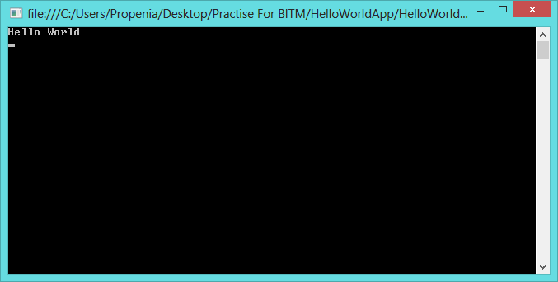

1. Take two numbers from user and show their addition, subtraction, division and multiplication result in console.

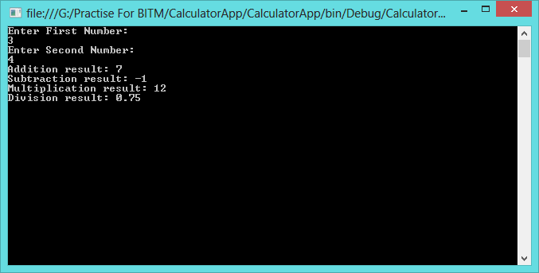

1. Take two numbers from user and tell which one is bigger and which one is small. If they are equal tell that they are equal.

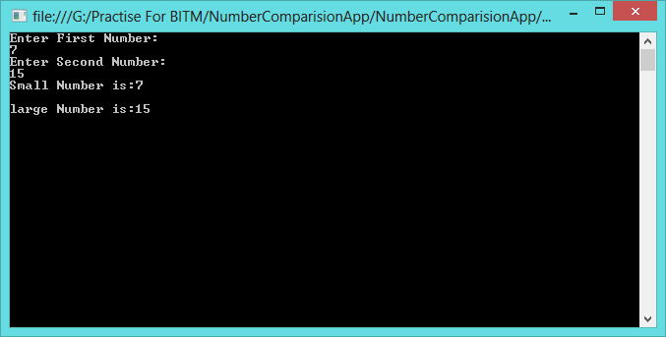

1. Take user name as input and show a greeting like: Hi, <user name> good day.

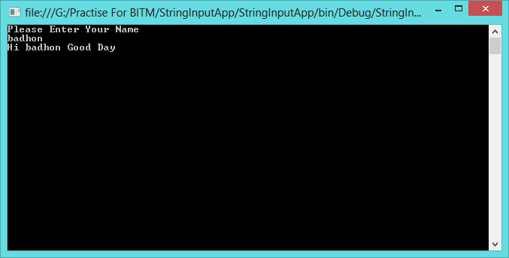

1. Show number from 1 to 100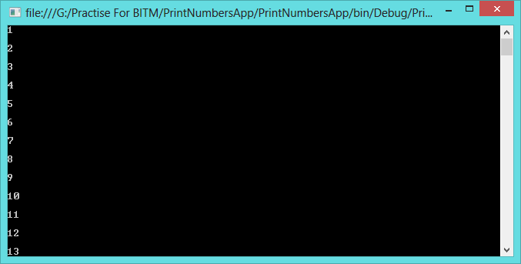
2. Take upper and lower limit from user and show all integers between them (including them).
3. Show all even number from 1 to 100

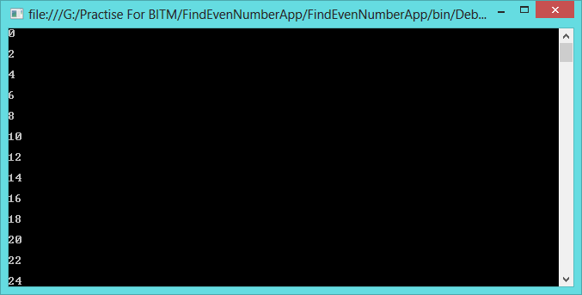

1. Show first 100 Fibonacci number.

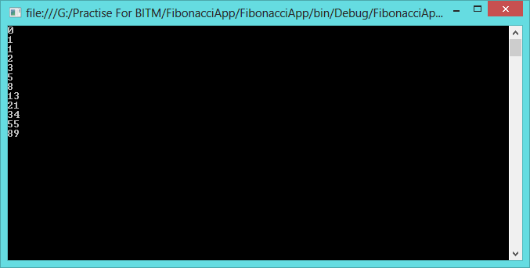

1. What is windows registry? Read a show all windows registry using a C# program.

Help: i.<http://en.wikipedia.org/wiki/Windows_Registry>

ii. <http://www.codeproject.com/Articles/3389/Read-write-and-delete-from-registry-with-C>

1. What is the format CSV file?
2. What is environmental variable? Show all environmental variables and their value in C#.

Help:i. <http://msdn.microsoft.com/en-us/library/1h5xxewc(v=vs.110).aspx>

ii. <http://en.wikipedia.org/wiki/Environment_variable>

1. What is event log in windows OS? See all event viewers in windows 8. Write a CSharp program to show eventlog in windows
2. Find all services running in windows. Write a program using C# to view all the running services in your windows.

Help: <http://www.csharp-examples.net/windows-service-list/>